**System setting-up for one type of product**

Please note that the following two steps (A and B) only need to be done once for each type of product and typically each step costs less than 1 minute.

1. **Create a reference image**
2. Put a food pack with its label at the correct position on the conveyor belt. The food pack should also be laid at a good position to make sure it is not rotated (or only slightly rotated) in the output image.
3. Build up a folder for this type of product. For example, name it as ‘Cod and crab bake’ and save the output image as ‘ref.jpg’ into the folder.
4. **Create a mask image**

1. Right click ‘ref.jpg’, select ‘Open with’ and then select ‘Paint’

2. In the ‘Colors’ panel in Paint, click ‘Color 2’ and then click the small black square on the right to set Color 2 to black.

3. Click ‘Select’ and then draw a box roughly around the label region in the reference image, shown as below:

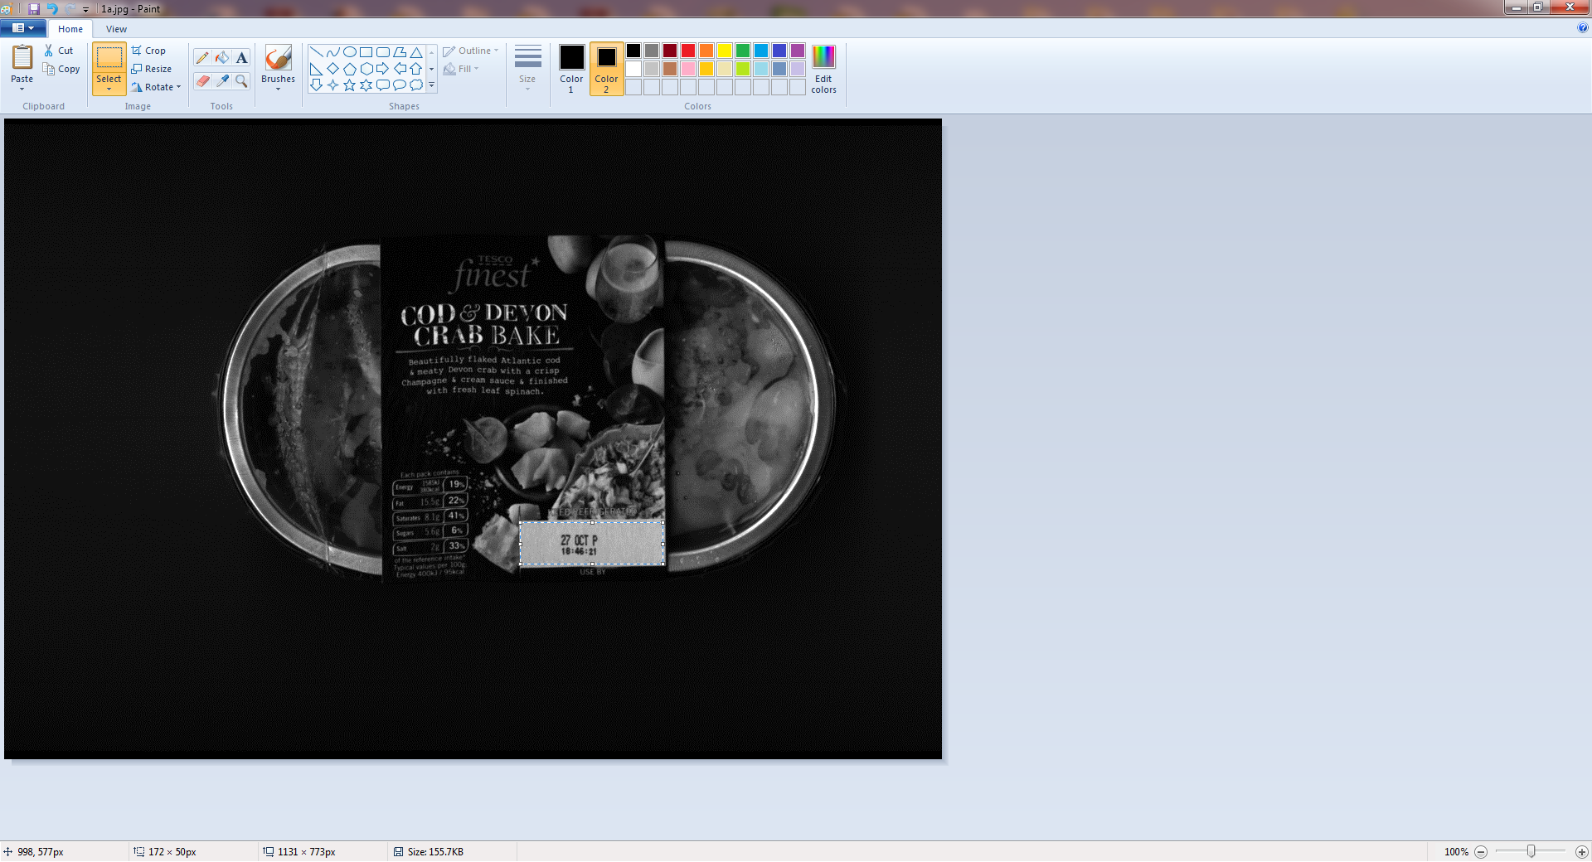

4. In the dropdown menu of ‘Select’, select ‘Invert selection’ and then select ‘Delete’.

5. Set ‘Color 2’ to white (similar to step 2).

6. Click the rectangle icon in the ‘Shapes’ panel and set ‘Outline’ to ‘No outline’ and ‘Fill’ to ‘Solid color’.

7. Draw a rectangle slightly larger than the label region to fully cover it.

8. You should now end with a mask image shown as below. Save it into the folder of ‘Cod and crab bake’ using the file name ‘mask.jpg’ (or mask0.jpg, mask1.jpg … if you need to detect more than one labels).

